FAST National University of Computers Engineering and Sciences



Digital Logic Design

Aegis Grid Project

Members:
Soha Khan 25K-0596
Syeda Hira Batool 25K-0652
Tehreem Anwar 25K-0667

Teacher’s Name: Sheeraz Iqbal

Submission Date: May 04, 2026
Introduction:

Sometimes we need to track a moving target and trigger an alarm when it reaches a specific spot. Using computers or microcontrollers can be complicated and expensive. The Aegis-Grid project solves this by using a simple hardware system. It tracks a target on a grid and rings an alarm only when the target hits a pre-set matching coordinate.

Objectives:

- To build a hardware system that tracks a target (like a finger or a laser) across a 16-position (4x4) grid.
- To save parts by tracking the target with only 8 sensors instead of 16 sensors.
- To convert the sensor signals into a 4-bit binary position
- To compare the target's position with a pre-set guard position and turn on status lights.
- To turn the led light red only if the target is in the exact right spot AND a safety switch is turned ON.

Hardware Requirement:

1. 74148 IC (Priority Encoder): 2 pieces. They read the 8 sensor wires (4 for X-axis, 4 for Y-axis) and turn them into binary bits.
2. 7485 IC (Magnitude Comparator): 1 piece. It compares the live target position against our pre-set position.
3. 7408 IC (AND Gate): 1 piece. It acts as a safety switch before letting the alarm ring.
4. 7404 IC (NOT Gate): 1 piece. It flips the sensor logic signals so they work correctly with the comparator.
5. LDRs (Light Sensors): 8 pieces. Light-dependent resistors placed in rows and columns to find the target.
6. 4-DIP Switch: 1 piece. Used to manually set the target guard position.
7. Standard Breadboard: 1 piece. The base where all parts are plugged in and connected.
8. LEDs & Buzzer: 3 LEDs (Yellow, Green, Red) and 1 Buzzer to show the status and sound the alarm.
9. Resistor Pack: 10 ohm resistors for the sensors and 330 ohm resistors to protect the LEDs.
10. 9V Battery, Clip & 7805 Regulator: Power source that drops 9V down to a safe 5V for the system.

Software Requirement:

LogicWorks: Digital circuit software used to design, draw, and test the system before building it.

Members work distribution:
· Tehreem (Hardware Lead): Tehreem did the main hardware implementation. She placed the chips on the breadboard, arranged the 8 LDR sensors into the grid layout, and wired the complete circuit together.
· Hira (Software & Hardware Support): Hira designed and tested the whole circuit simulation inside the LogicWorks software.She also helped Tehreem on the hardware side with component placement and testing the circuit connections.
· Soha (Documentation & Hardware Support): Soha wrote the project proposal abstract and the final report. She also helped Tehreem build and connect the physical hardware components on the breadboard.
Implementation:
· Sensors to Encoders: Connect the 4 column sensors (X-axis) to inputs 0 to 3 of the first 74148 encoder. Connect the 4 row sensors (Y-axis) to inputs 0 to 3 of the second 74148 encoder. Ground the EI pin on both.
· Inverting the Signals: Send the outputs of the encoders through the 7404 NOT gate to make them positive signals. Stitch these 4 lines together to get a 4-bit live coordinate (B).
· Comparing the Target: Connect the DIP Switch (Guard Position A) to the 'A' inputs of the 7485 comparator. Connect the live position (B) to the 'B' inputs.
· Safety Trigger: Connect the A=B (Locked) output pin from the comparator to Pin 1 of the 7408 AND gate. Connect the Master Arm toggle switch to Pin 2. Connect Pin 3 (Output) to the Red LED.
Circuit Explanation:
· The Matrix Layout: Instead of using 16 separate sensors for 16 spots, we use a grid of 8 sensors (4 for X and 4 for Y). This saves parts and makes wiring much easier.
· Priority Function: The 74148 chip is a priority encoder. If more than one sensor is covered at the same time, it always picks the highest numbered wire to stop errors.
· The Safety Function: The LED doesn’t turns on by accident. Even if the target passes over the guard position, the AND gate blocks the alarm unless the user flips the "Master Arm" switch to ON.
Results:
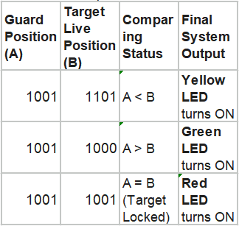
Hardware Implementation:

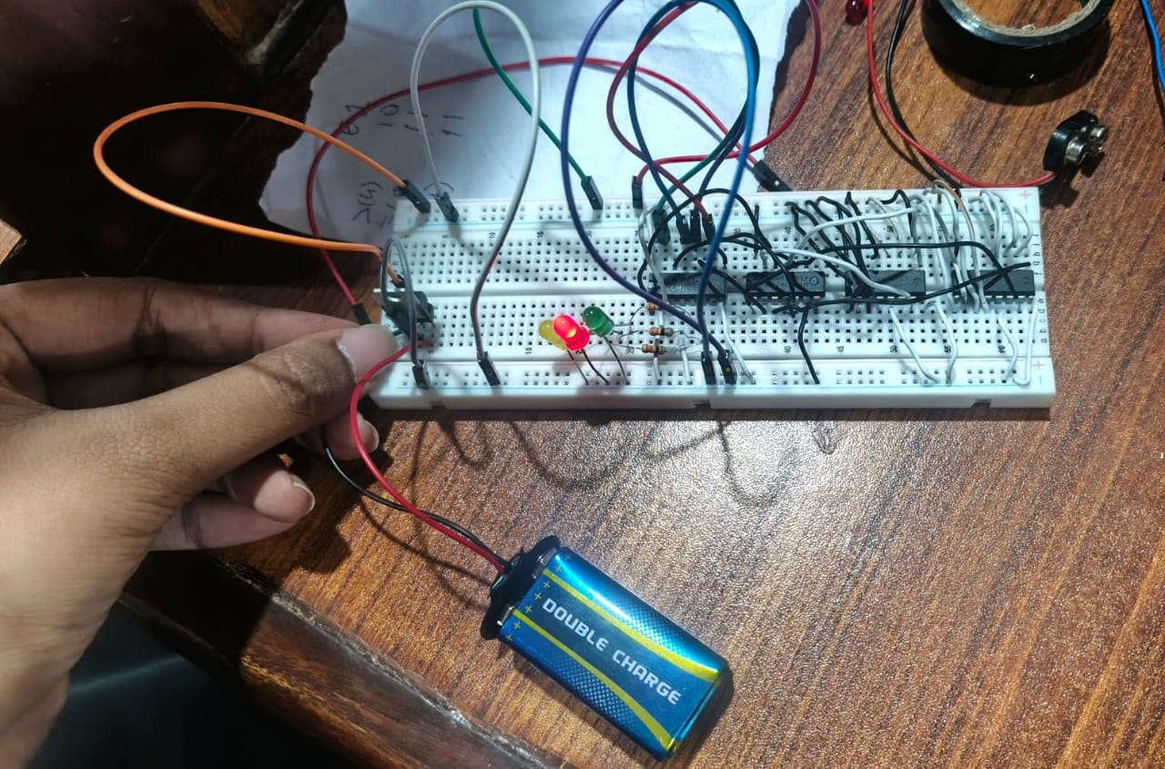

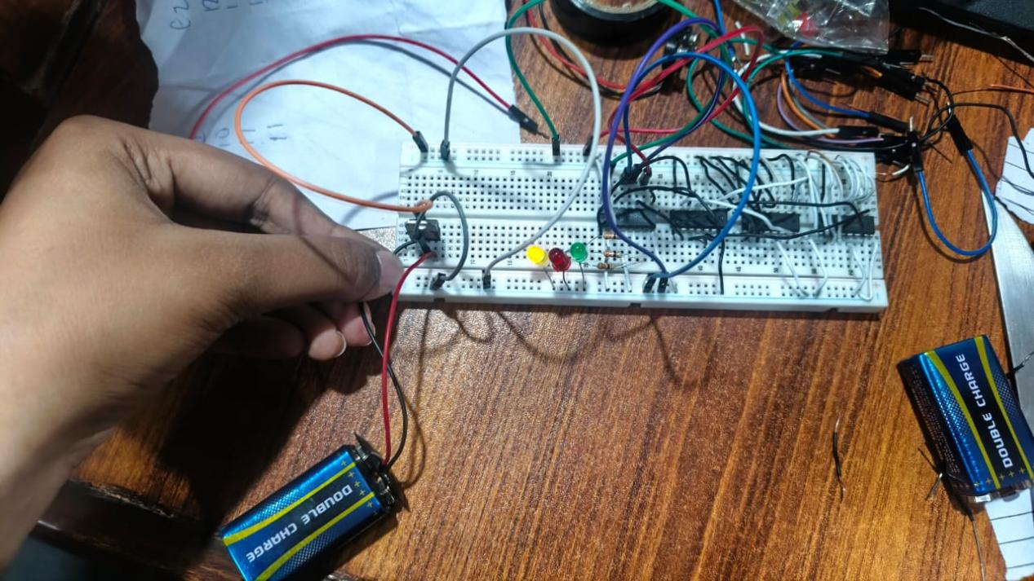

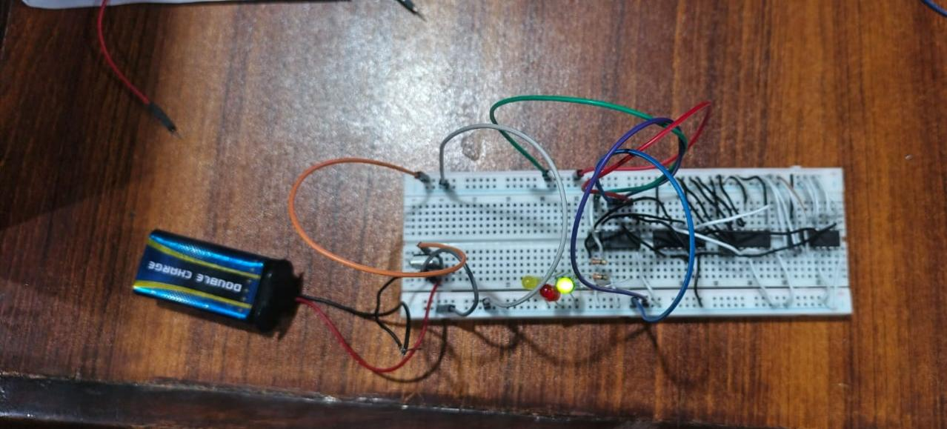

Software Implementation:
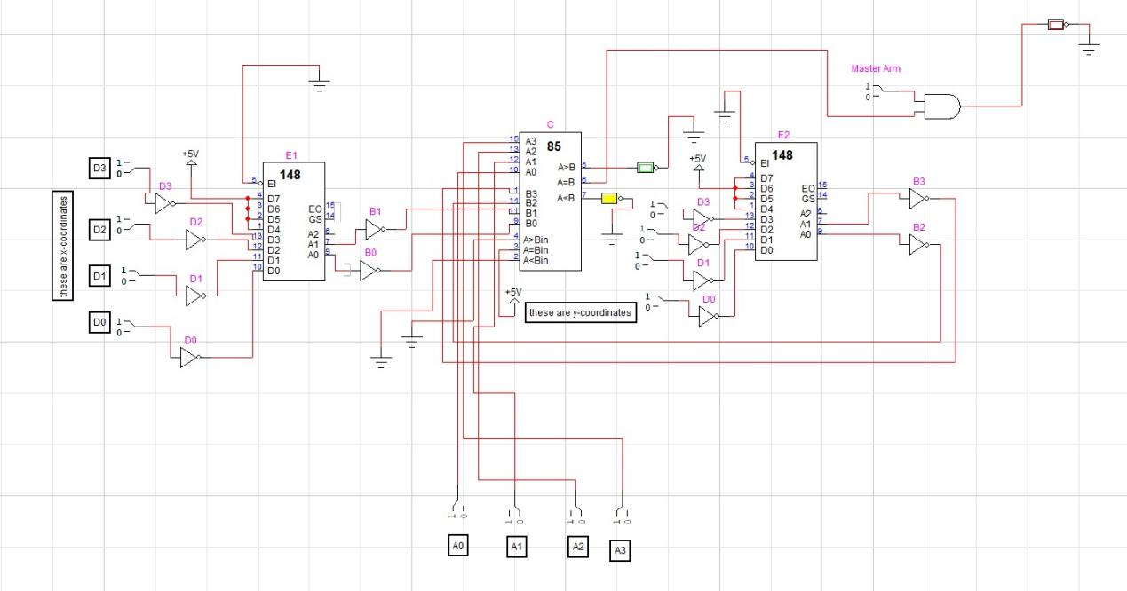
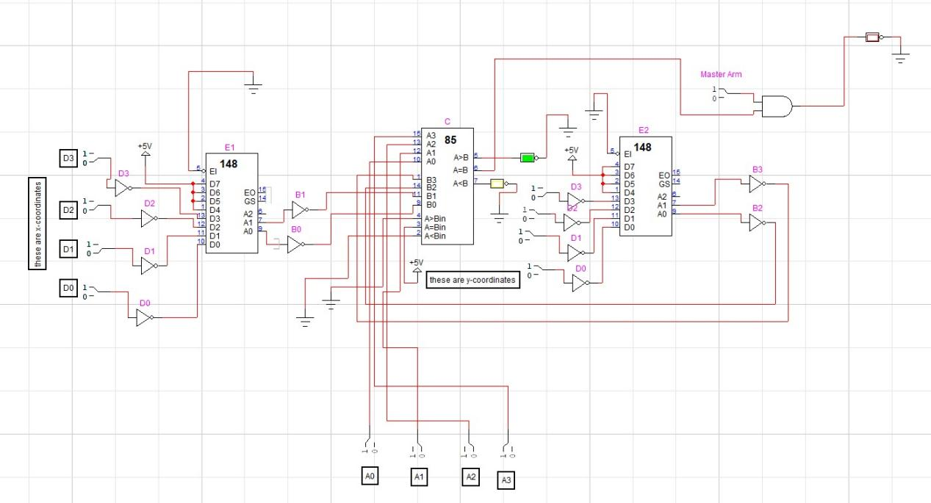
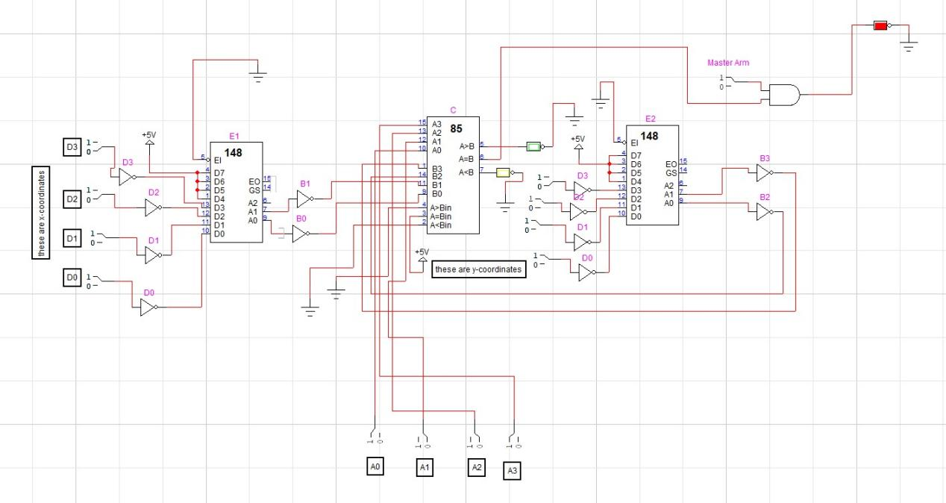

Conclusion:
· We learned how to use a grid matrix to control a 16-position area with only 8 sensor wires.
· We learned how to use a NOT gate to fix active-low signal issues between different types of IC chips.
· We learned how an AND gate works as a physical safety lock to stop electronic alarms from misfiring.

References:
- Gemini: To understand and implement hardware logic in a better way.
- Project Abstract.

